* **Backend**

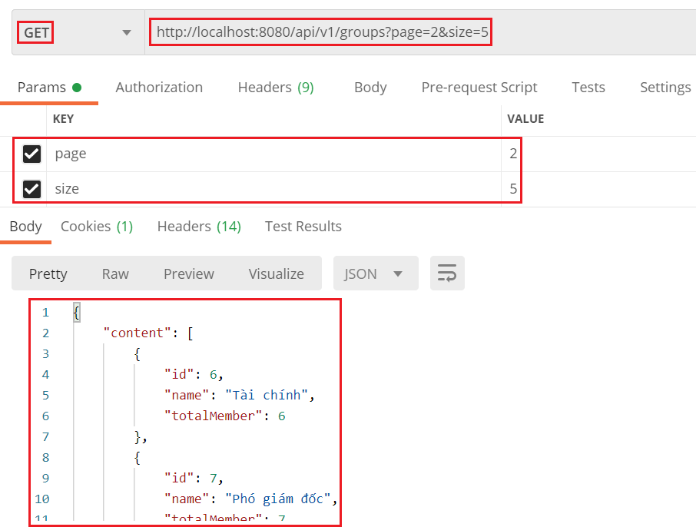

*Đính kèm Token vào header để get groups*

* **Frontend**

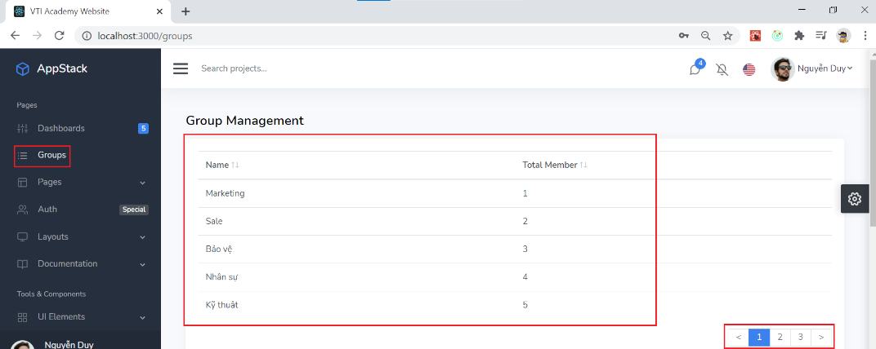

*Sử dụng redux và redux-thunk để quản lý state*

* + Paging
    - <https://react-bootstrap-table.github.io/react-bootstrap-table2/storybook/index.html?selectedKind=Remote&selectedStory=Remote%20Pagination&full=0&addons=1&stories=1&panelRight=0&addonPanel=storybook%2Factions%2Factions-panel>
    - <https://react-bootstrap-table.github.io/react-bootstrap-table2/storybook/index.html?selectedKind=Pagination&selectedStory=Custom%20Pagination&full=0&addons=1&stories=1&panelRight=0&addonPanel=storybook%2Factions%2Factions-panel>
* **Reference**